Secure Point-to-Point Instant Messaging System Applied Cryptography Project Report
Group Members - Markus Means, Ian Dang, Jackson McKay

1. Introduction
Secure instant messaging is a core problem in applied cryptography. Tools like Skype, Google Talk, and iMessage need to make sure that messages sent over the public internet cannot be read or tampered with by anyone other than the intended recipient. In this project, we built a working peer-to-peer (P2P) instant messaging application that handles this problem using standard cryptographic techniques.
The application is called SecureChat P2P and is written in Python. It uses the Tkinter library for the GUI, PyCryptodome for the symmetric ciphers and PBKDF2, and Python's standard hashlib and built-in big-integer arithmetic for the Diffie-Hellman exchange. Two users, Alice and Bob, connect to each other directly over TCP, derive a shared encryption key from a password, and exchange encrypted messages in real time. The system meets all the project requirements: a key length of at least 56 bits, proper key derivation from the password, random IVs so the same message always produces different ciphertext, a GUI that shows the ciphertext and decrypted plaintext, socket-based networking, and a key rotation mechanism that updates the key every 60 seconds. We also implemented two extra credit features: a double-cipher mode that combines AES and ChaCha20, and a Diffie-Hellman key exchange so no pre-shared password is needed.

2. System Architecture
The application has three layers that work together. The cryptographic layer handles all encryption and decryption. The network layer manages the TCP connection and message framing. The GUI layer handles user interaction and displays messages.
Alice runs the application in server mode, meaning she listens on a port and waits for Bob to connect. Bob runs in client mode and connects to Alice's IP address and port. Once connected, either side can send messages. All network operations run on a background thread so the interface stays responsive while waiting for messages.
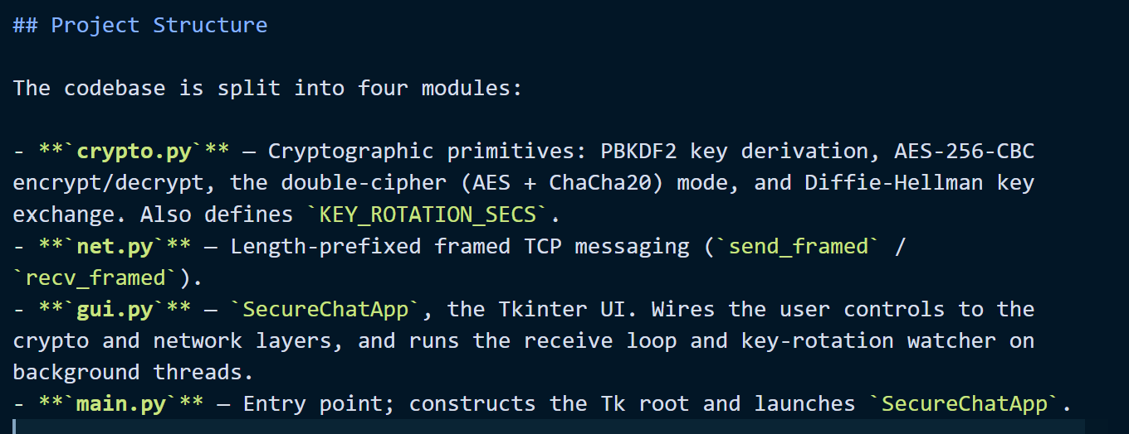

3. Cryptographic Design
3.1 Cipher Choice
The project requires a key of at least 56 bits. We chose AES-256-CBC, which uses a 256-bit key. This is well above the minimum and is considered secure against brute-force attacks with any currently known technology. AES was selected by NIST in 2001 as the standard symmetric encryption algorithm after an international competition. We use CBC mode because it chains each block of ciphertext to the previous one, which means identical blocks of plaintext in different positions will produce different ciphertext.
3.2 Key Derivation
We never use the password directly as a key. Passwords are short and easy to guess, so using one as a key would make the system weak against dictionary attacks. Instead, we use PBKDF2-HMAC-SHA256 to derive a proper 256-bit key from the password. The function is called with 200,000 iterations, which means each attempt to guess a password takes a significant amount of time even on fast hardware. This makes brute-force attacks much slower. The salt used in the derivation is a fixed shared constant combined with the current epoch number, which ensures the derived key is unique for each time window.
3.3 Random IVs and Ciphertext Randomization
One of the requirements is that sending the same message twice should produce different ciphertext. We achieve this by generating a new random 16-byte initialization vector (IV) for every single message. The IV is prepended to the ciphertext so the receiver can use it to decrypt. Because the IV is random each time, encrypting "ok" twice will give two completely different outputs even with the same key.
3.4 Padding
AES works on 16-byte blocks, so any message that isn't a multiple of 16 bytes needs to be padded first. We use PKCS7 padding, which adds bytes equal in value to the number of bytes added. For example, a 13-byte message gets 3 bytes of 0x03 appended. A message that is already 16 bytes gets a full extra block of 0x10 added so that padding is always present and can always be removed correctly on the other end.
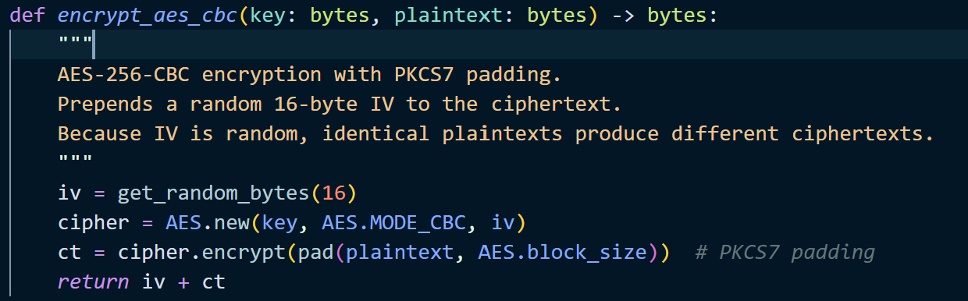
3.5 Key Rotation
We implemented a key rotation mechanism that automatically changes the encryption key every 60 seconds. We do this using an epoch counter — an integer that increments every 60 seconds based on the current Unix timestamp. Both Alice and Bob compute the same epoch independently from their system clocks and include it in the PBKDF2 derivation, so their keys stay in sync without any extra communication. A background thread watches for epoch changes and logs a notification in the GUI whenever the key rotates. To handle messages sent right at the boundary between two epochs, the receiver in single-cipher (AES-256-CBC) mode tries decrypting with the stated epoch and also the one before and after it.
This improves security because even if someone somehow obtained the current key, they could only decrypt messages from the current 60-second window. All previous messages remain protected under their old keys.
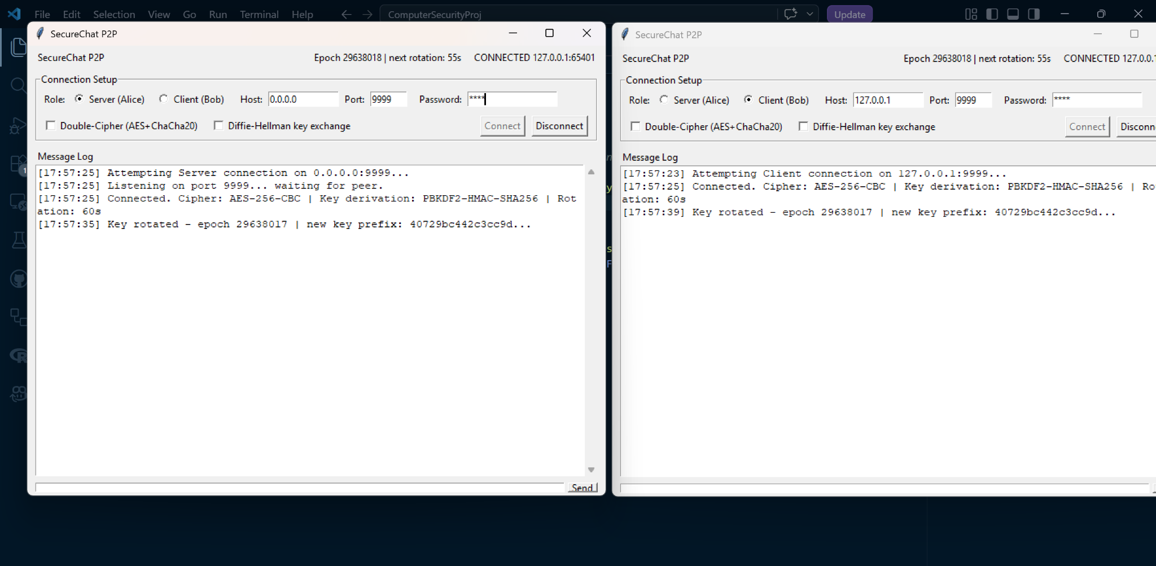

4. Network Design
The application uses TCP sockets for communication. We chose TCP over UDP because it guarantees that messages arrive complete and in order, which is important for a chat application.
Because TCP is a stream protocol with no built-in message boundaries, we use a simple framing scheme: every message is sent with a 4-byte length prefix that tells the receiver exactly how many bytes to read. The payload itself is a JSON object with two fields: the epoch (so the receiver knows which key to use) and the base64-encoded ciphertext.

5. GUI Design
The GUI is built with Python's Tkinter library. It has four main sections: a title bar showing connection status and epoch info, a connection setup panel with role selection, host/port/password fields, and feature checkboxes, a scrollable message log, and a text input row at the bottom.
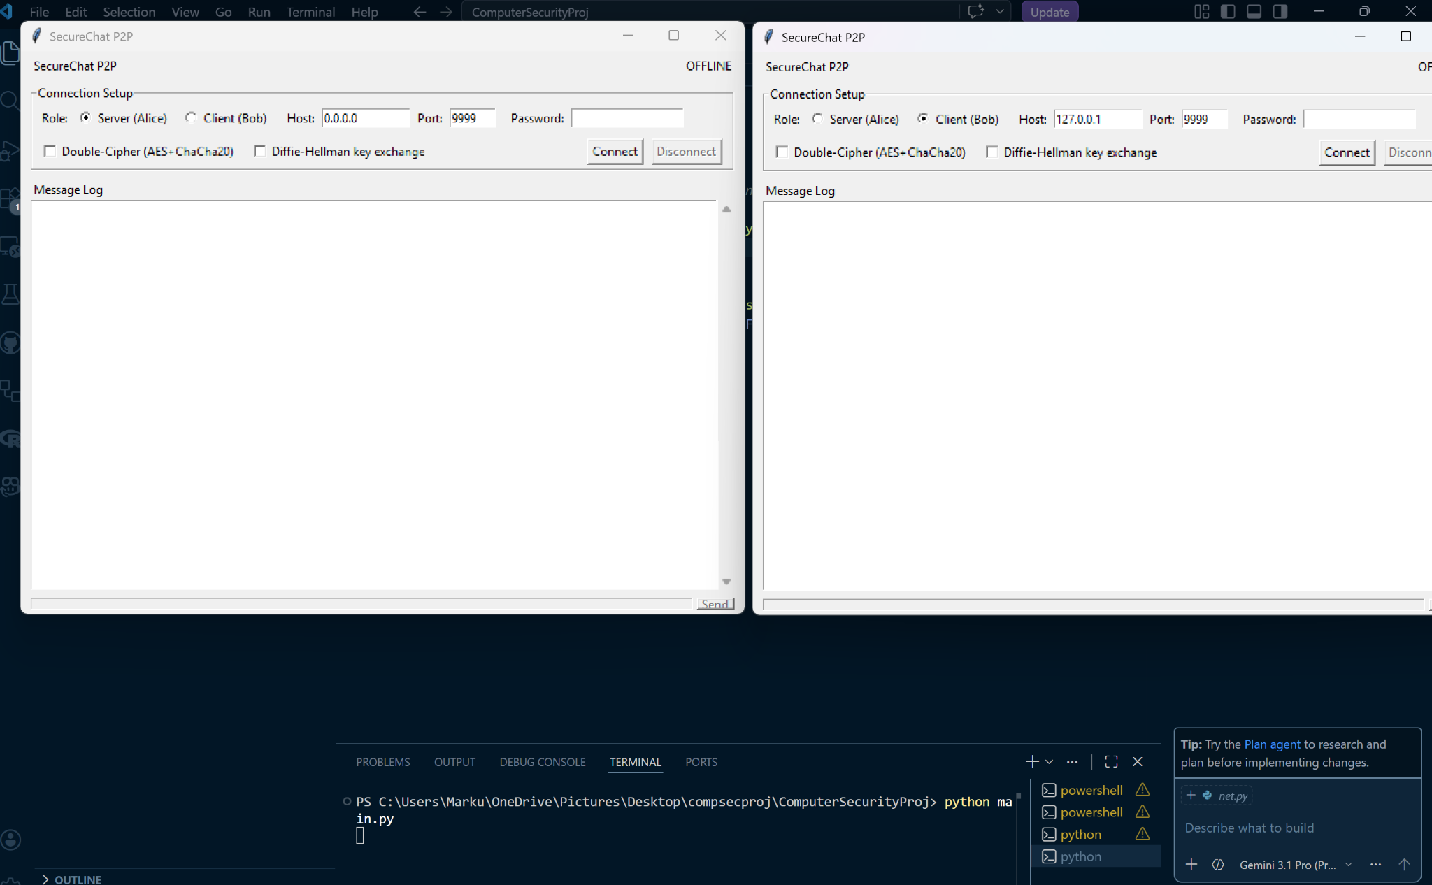
When a message is sent, the log shows the plaintext you typed and the base64-encoded ciphertext that was transmitted. When a message is received, the log shows the received ciphertext and then the decrypted plaintext below it. Key rotation events are logged with a timestamp and the first few characters o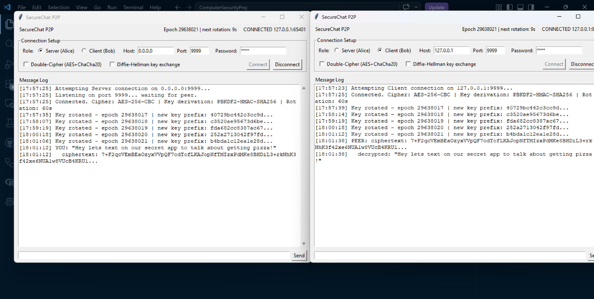f the new key so users can see when the key changes. The current epoch number and the seconds remaining until the next rotation are shown in the title bar and refresh every two seconds.

6. Security Analysis
The system protects against a passive eavesdropper on the network who can see all traffic between Alice and Bob. The key properties are: AES-256 provides 256 bits of key security, well above the 56-bit minimum. PBKDF2 with 200,000 iterations makes password guessing slow. Random IVs ensure ciphertext is different every time even for repeated messages. 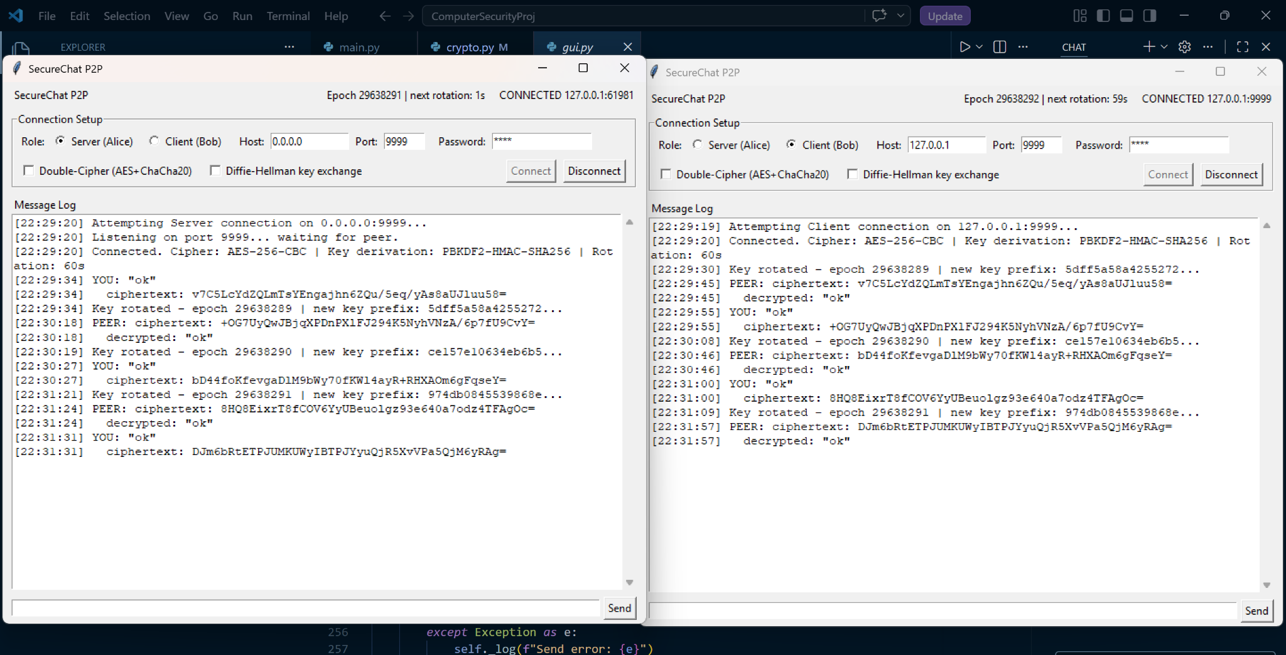Epoch-based key rotation limits how much data any single key protects to at most 60 seconds of traffic, which also caps the value of any compromise of a single derived key.
Forward secrecy is partial. In password mode, an attacker who later learns the passphrase can recompute every past epoch key and decrypt any traffic they recorded, because the salt and epoch counter are both public. In DH mode the keying material is ephemeral and only lives in process memory, so an attacker who later compromises a host cannot recover earlier conversations.
The system has several known limitations. It does not include a message authentication code (MAC), so an active attacker could flip bits in the ciphertext in transit; combined with PKCS#7 padding and CBC mode, this also exposes the system to a padding oracle attack if an attacker can observe whether decryption succeeded. Adding HMAC over the ciphertext (encrypt-then-MAC) would close both of these. There is also no per-session nonce or sequence number, so a captured ciphertext can be replayed within the same 60-second epoch and will decrypt cleanly on the receiver. Finally, the Diffie-Hellman exchange is unauthenticated, so a man-in-the-middle attack is theoretically possible if the attacker can intercept and replace the public values before they arrive.

7. Testing
We tested the application by running two instances on the same machine. Alice ran in server mode on port 9999 and Bob ran in client mode connecting to 127.0.0.1:9999. Both used the same password. After connecting, we sent messages in both directions and verified that the ciphertext displayed in the log was different each time even for the same message, confirming that IV randomization is working. We waited 60 seconds to verify that the key rotation notification appeared in both windows with a matching new key prefix. We also tested double-cipher mode and confirmed the ciphertext format was different (longer, with the 0xEC flag prefix). Finally, we tested DH mode with no password and confirmed that both sides derived and displayed the same shared key.

8. Conclusion
We built a working secure P2P messaging application that satisfies all the project requirements. The system uses AES-256-CBC with PBKDF2 key derivation, random IVs, PKCS7 padding, epoch-based key rotation, and a Tkinter GUI that displays ciphertext and plaintext. We also implemented two extra credit features: a double-cipher mode combining AES and ChaCha20, and a Diffie-Hellman key exchange. The application demonstrates the practical application of the cryptographic concepts covered in class in a realistic networking context.

9. Extra Credit Features
9.1 Double-Cipher Mode (AES XOR ChaCha20)
When this mode is enabled, each message is protected by two ciphers at once. First, the plaintext is encrypted with AES-256-CBC to produce a ciphertext. Then, a separate ChaCha20 key is derived from the same password using a different salt, and a fresh 12-byte random nonce is generated for each message. ChaCha20 is used with that key and nonce to produce a keystream the same length as the AES ciphertext. The final output is the AES ciphertext XORed with the ChaCha20 keystream. The transmitted packet is laid out as a 1-byte mode flag (0xEC), followed by the 16-byte AES IV, the 12-byte ChaCha20 nonce, and the XORed ciphertext.
The security benefit is that an attacker would need to break both AES-256 and ChaCha20 at the same time to recover the plaintext. Since the two keys are derived independently, breaking one gives no information about the other.
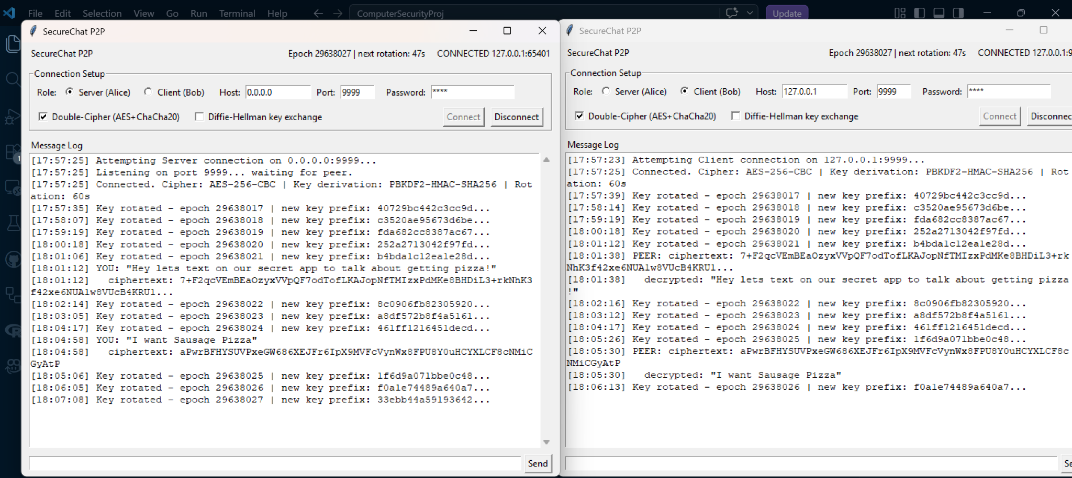
The Double-Cipher checkbox is enabled. The resulting ciphertext (seen in the log at 18:04:58) is a composite string consisting of an AES initialization vector, a ChaCha20 nonce, and the XORed output of both ciphers. This effectively layers two mathematically distinct encryption standards (NIST-approved AES and Bernstein’s ChaCha20) to prevent decryption even if one algorithm were theoretically compromised.

9.2 Diffie-Hellman Key Exchange
Normally both users need to agree on a password before they start chatting. With DH mode enabled, this isn't necessary. Immediately after the TCP connection is made, both sides generate a random private key and compute a public value using the RFC 3526 Group 14 2048-bit prime. They exchange these public values over the channel. Each side then computes the same shared secret (g^ab mod p) from the other's public value and their own private key. This shared secret is hashed with SHA-256 and the resulting 256-bit value replaces the user-entered passphrase as the input to the existing PBKDF2 chain, so per-epoch key rotation continues to work the same way as in password mode.
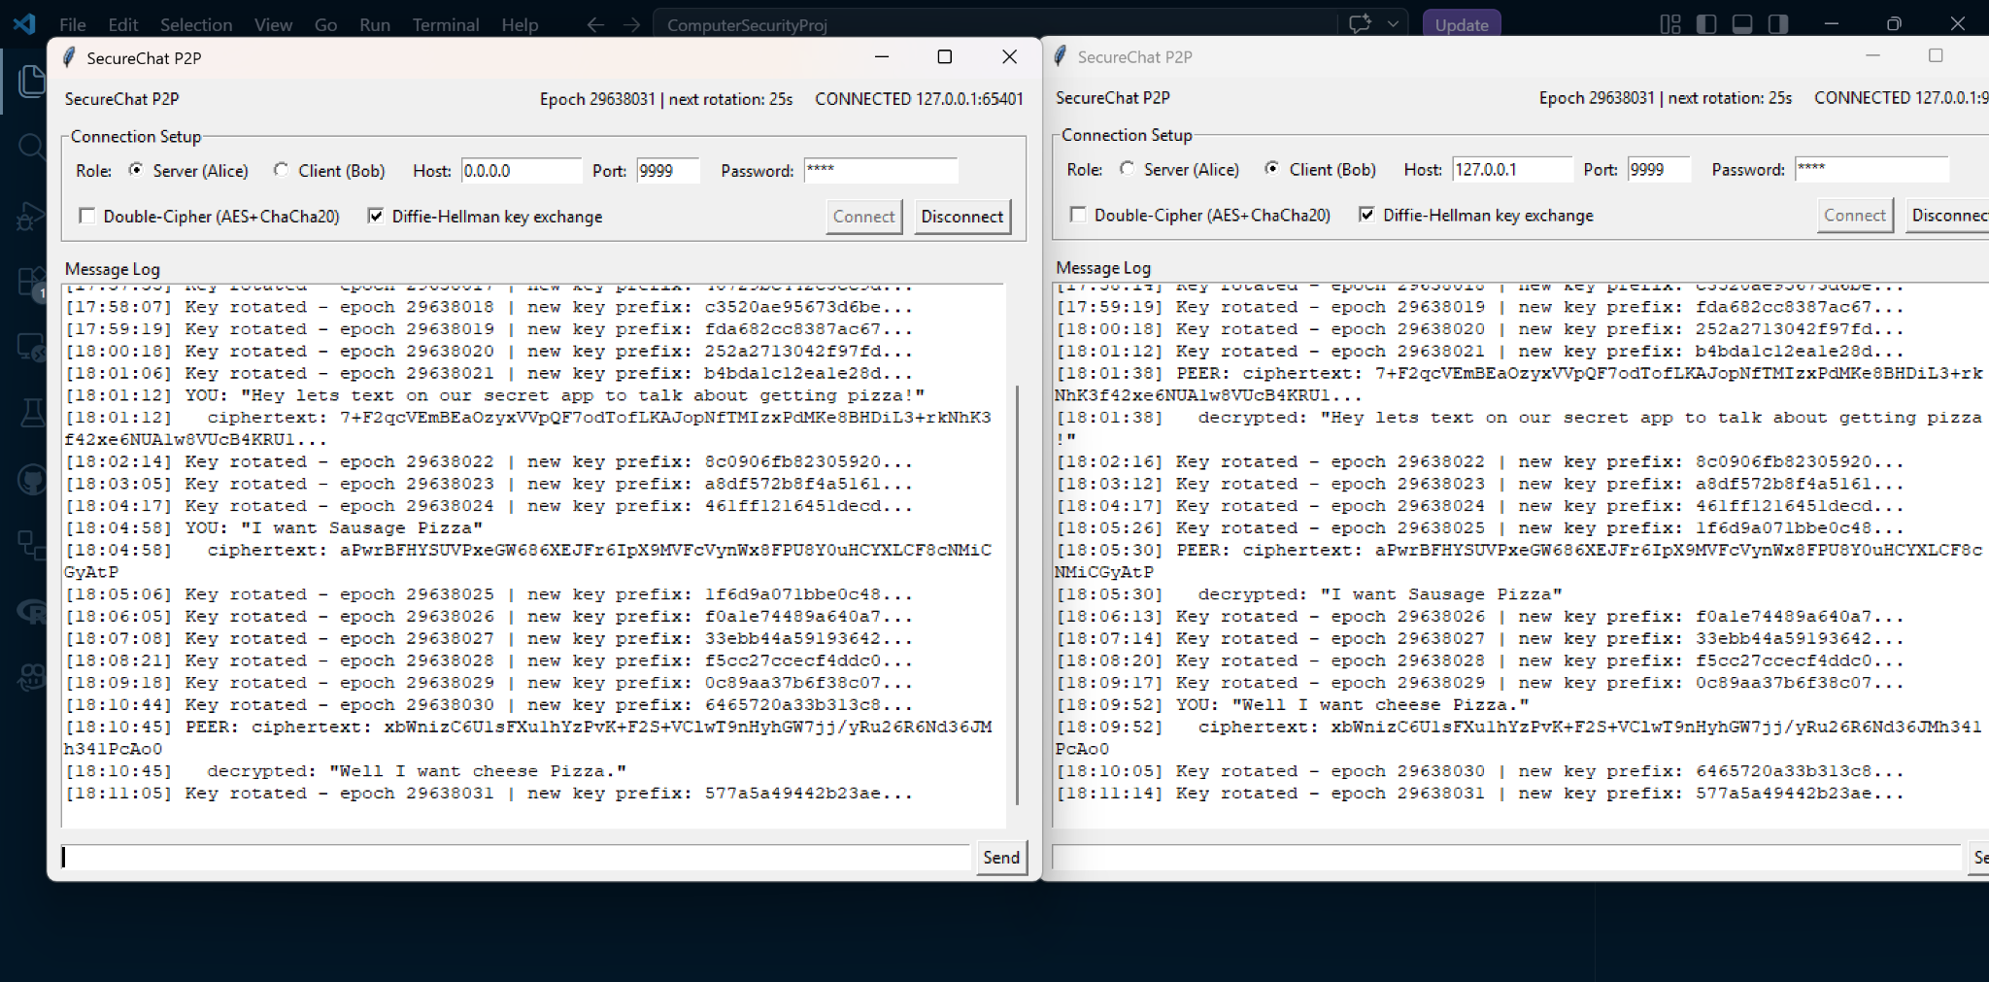
An eavesdropper who sees the public values exchanged cannot compute the shared secret without solving the discrete logarithm problem, which is computationally infeasible for a 2048-bit prime.

References
NIST. (2001). Advanced Encryption Standard (AES). FIPS PUB 197.
Moriarty, K., Kaliski, B., & Jonsson, J. (2017). PKCS #5: Password-Based Cryptography Specification Version 2.1. RFC 8018.
Kivinen, T., & Kojo, M. (2003). More Modular Exponential (MODP) Diffie-Hellman groups for Internet Key Exchange (IKE). RFC 3526.
Bernstein, D. J. (2008). ChaCha, a variant of Salsa20. Workshop Record of SASC.
PyCryptodome Documentation. https://pycryptodome.readthedocs.io/

